Winners Curse with system dynamics

Angie moon

Introduction

There are no permanent winners. Even if the leader responds a little, the follower will not be able to catch up, so why does the reversal occur? How this phenomenon occurs is to be investigated through a system dynamics approach.

There is a stagnant market. A total of 100 customers live in this market. Leader has 50 of these customers. This is when followers jump into the market. There are only two strategies that leaders and followers can choose: a push strategy and a pull strategy. The push strategy is assumed to be a strategy that encourages people around you to purchase by providing promotions to customers who have purchased. The full strategy uses advertising. It is assumed that the effects of the pull strategy and the push strategy are independent of each other. It is assumed that the effect of the push strategy and the effect of the pull strategy are the same for both the leader and the follower.

As a result of the simulation, if the followers follow the leader's strategy, the leader cannot defeat the followers. The winner's curse is inevitable.

Research Background

System dynamics is the study of analyzing the behavior of a system. It would be nice to understand that actions are different from actions and are the results that appear over time. The system consists of flow and stock variables. System dynamics is the study of analyzing the behavior of a system. It would be nice to understand that actions are different from actions and are the results that appear over time. The system consists of flow and stock variables. Examples of a typical system are shown in Figure 1.

Figure 1 Examples of systems

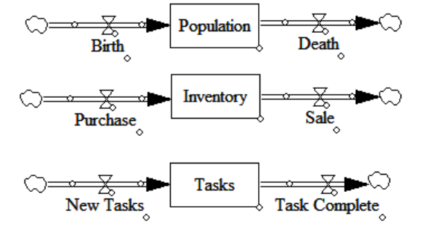

Population, inventory, and task boxed in the middle in Figure 1 are stock variables. The inputs and outputs of stock variables are called flow variables. Stock is the accumulated difference between inflow and outflow.

An open system has feedback. Since there is no feedback in Figure 1, it is not called an open system. Feedback is the process of making a purchase because the inventory is small. Feedback is made up of relationships between variables, and those relationships make a loop. Looking at the simultaneity of the relationship, a positive loop and a negative loop are distinguished. If the direction changes when going around the loop once, it is a negative loop, and if it does not change, it is a positive loop.

One negative loop can lead to a systemic behavior called goal seeking. One positive loop creates a behavior called exponential growth or exponential decay. When one negative loop and one positive loop meet, an S-shape is created. Of course, this isn't always the case. It depends on the parameter value used for the relationship between the variables. Some loops may be formed but not dominant, or not even functioning. You can guess which loops are contained in the system by looking at the behavior of the system, but it is not easy to infer which behaviors will be derived by looking at which loops. This is also due to the degree of influence of the parameters discussed above.

f the number of loops is more than 3, it is not easy to infer the behavior of the system. It is also not easy to determine which loops are inherent when the behavior of the system appears. Such a case is called a complex world. System dynamics is an attractive approach in that it allows you to dig through a complex world loop by loop.

Figure 2 SI and PA Model

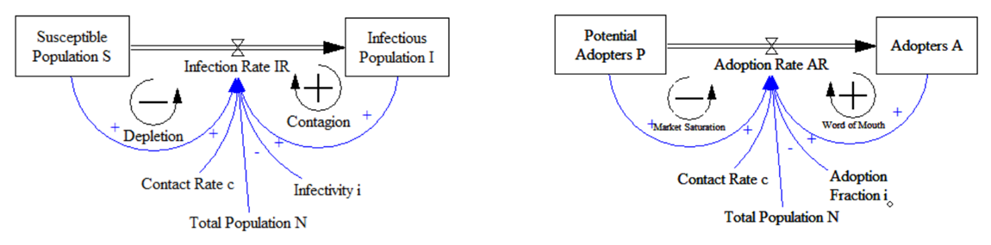

The Adoption Rate (AR) per unit time (here, 1 day for convenience) is determined as follows.

AR= A*c*i*P/N

AR : Adoption Rate

A: Adopters

c: Contact Rate

i: Adoption Fraction

P: Potential Adopters

N: Total Population

An adopter meets and introduces 6 people a day, among which the ratio of potential adopters (40 people) is P/N (the total population is 100 people and the number of adopters is 60 people), and the probability of success is Assuming 0.02 (2%), the amount newly adopted per day is 2.8 people/day.

AR = 60*6*0.02*0.4= 2.8

Figure 2 is the SI model consisting of two stocks and one flow. Although it is expressed relatively simply, a logistic function is inherent, two loops are operated, and it generally represents an S-shape. Primarily, the SI model is heavily utilized when implementing the spread of an epidemic such as Covid. A similar PA model is often used to represent a new technology or marketing strategy.

Figure 3 BASS Diffusion Model with Replacement Purchase

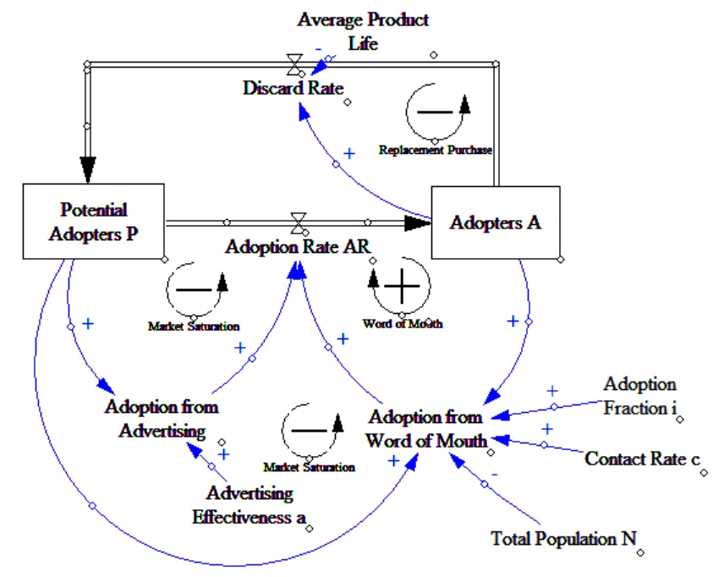

The BASS model reflects advertising and word-of-mouth effects by applying the PA model in Figure 2. The BASS model expressed advertising and word-of-mouth effects. The PA model has the characteristics of compensating for the small initial AR value. The replacement purchase loop is added to the model in Figure 3. At this time, adopters mainly show S-shape. Adopters return to potential customers after using the product for a period of time. <Figure 3> The model contains four loops, so it is difficult to guess what behavior it will show. Depending on the parameters, different system behaviors emerge. Overall, it is a form that returns through the Discard Rate flow, and it is a model that cannot diverge because it moves within the Total Population.

Simulation Model

In this study, the model in Figure 3 was expanded and a model that reflected strategic behavior was constructed. The advertising was renamed the pull strategy, and the word of mouth strategy was named the push strategy.

Figure 4 Simulation model in this study

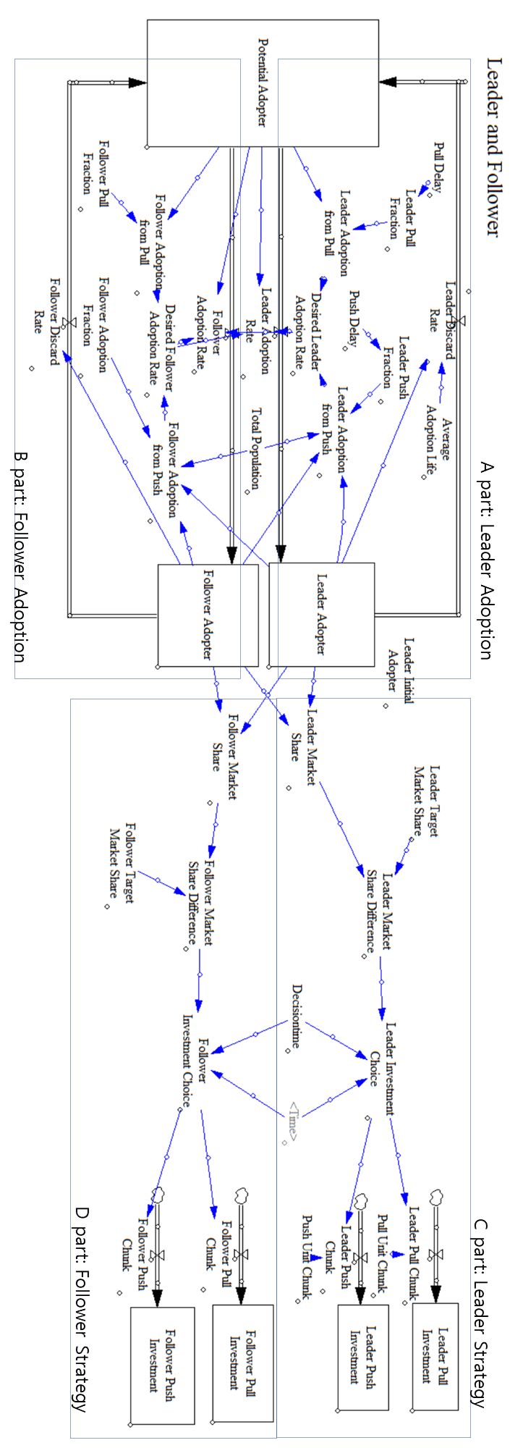

The same 0.05 was applied to both the effect of the push strategy and the effect of the pull strategy. However, the pull strategy works by a negative loop, and the push strategy affects AR by a positive loop. If the push strategy is continuously performed, the number of adopters can increase through exponential growth, and if the pull strategy is performed, the number of adopters of the goal seeking type is expected to increase.

In Figure 3, parts C and D depict the expansion of leader and follower strategies. Leader Investment Choice acts as a kind of switch. When a leader loses his market share relative to his target market share, he chooses a push strategy and a pull strategy. Since the selection cannot be changed every day, the relational expression was set by inserting a period called Decisiontime. Here, it is assumed that strategy selection is made once every 30 days. Choosing a push strategy or a pull strategy increases the adoption effect. When it rises, it is modeled as rising as much as the basic unit (Leader Unit Chunk). The investment according to the strategy increases in a stepwise fashion based on a specific day. Leader Pull Fraction is initially 0.05%, and increases by 0.05% when the leader chooses the pull strategy.

There is a delay (here, a pull delay and a push delay) because the effect does not occur immediately when the investment is made. The delay time was set to 5 days. Delay3 was used as the delay function.

Detailed relational expressions are included in Appendix 1.

Simulation Results

1. When the follower follows the leader’s strategy

Just include the same number in the relationship between Leader Investment Choice and Follower Investment Choice.

Leader Investment Choice=IF THEN ELSE(MODULO( Time, Decisiontime)=0 :AND:Leader Market Share Difference>0, 2, 0)

In the above relationship, 2 is the case where the push strategy is selected, and 1 is the case where the pull strategy is selected. If you put 0 or other numbers other than 1 or 2, the expansion strategy is not used. The case where the expansion strategy is not used refers to the case where the influence of the push strategy and the pull strategy were initially 0.05, but they are maintained as they are.

First, the case where the leader and followers no longer expand the strategy was set as 00 and the simulation was run.

Figure 5 In case 00, market shares of leader and follower

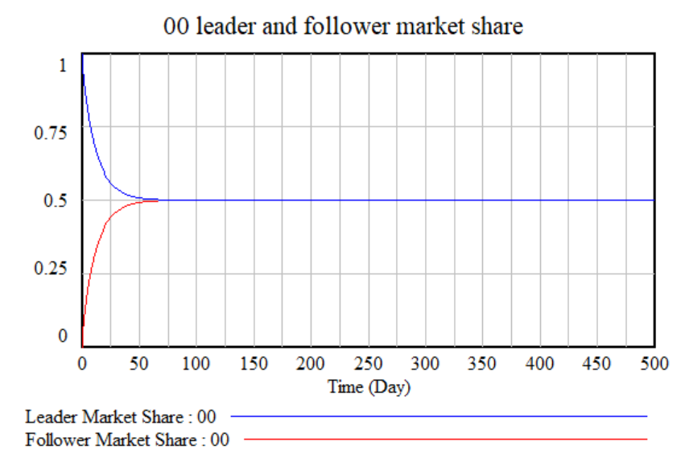

The follower's push strategy effect (although it does not expand any further) is insignificant at first compared to the leader's push strategy effect, but it gradually takes away the leader's market share. show %.

Compare the case where both the leader and the follower perform 1 strategy (full strategy). In other words, it can be said that it is a competition by utilizing the advertising effect and the like and using a negative loop. It is assumed that the initial value (0.05) of the push effect of both the leader and the follower is maintained.

Figure 6 In case 11, market shares of leader and follower

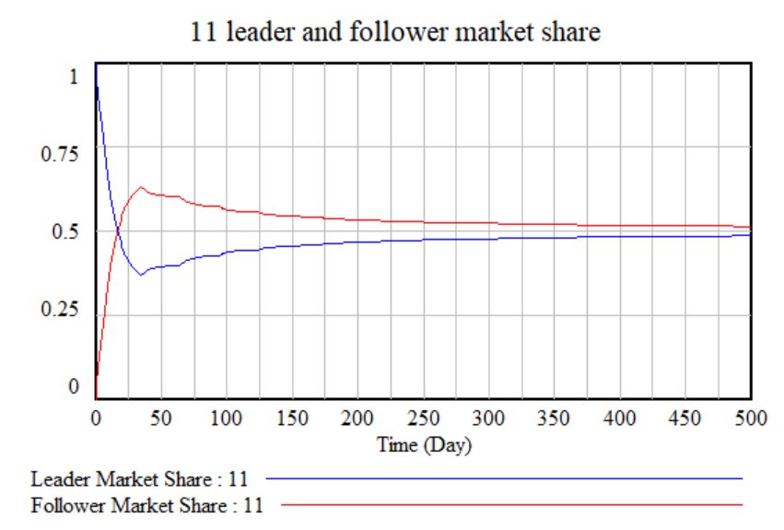

Followers' market share rises rapidly and exceeds 50% before the 25th. Then, it gradually decreases so that the market share of the leader and the follower proceeds to the same level. Since this simulation was performed only for 500 days, it did not reach the same level within 500 days. It should be noted that the leader's market share, once reversed, cannot be reversed as long as the same strategy is employed. However, the gap gradually narrows.

Let's take a look at a case where both the leader and the follower continuously expand the push strategy.

Figure 7 In case 11, market shares of leader and follower

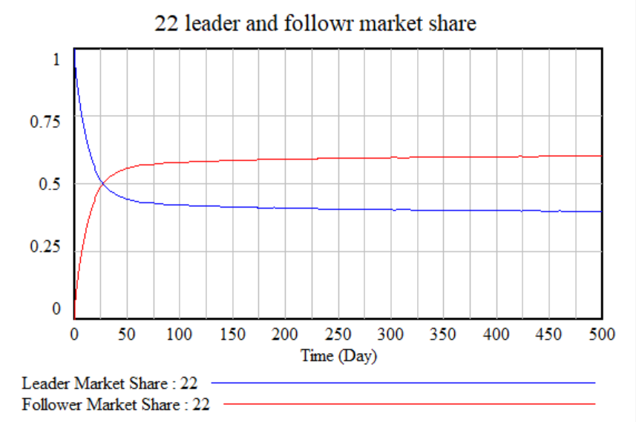

If both the leader and the followers continuously expand the push strategy, the leader continuously loses the market. The follower outstrips the leader's market share after 25 days, and continues to widen the market share gap. Leader's market share at 500 days is 0.3978. In the case of the push strategy, it is judged that the path dependency phenomenon appears because the positive loop operates.

1. Follower does not follow the leader’s strategy

The change in market share when the leader chooses the push strategy and the follower chooses the pull strategy is shown in Figure 8 below.

Figure 8 market shares in case(21) leader-push, follower-pull strategy

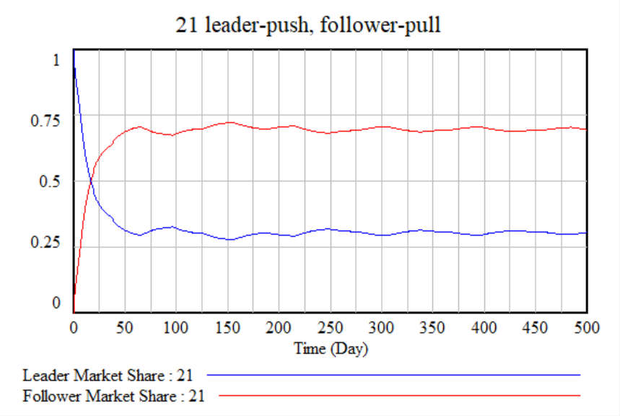

If the leader chooses the push strategy and the follower chooses the pull strategy, the follower has an absolute advantage. Before the 25th, the market share reverses. Only about 1/3 of the market is occupied by the leader. For followers, this is a good strategy to achieve your goals in a short period of time. The reason why the follower's market share fluctuates around 0.7 is because the Follower Target Market Share is set to 0.7. In other words, followers stop expanding the full strategy when their market share exceeds 70%. At this time, the competitor, the leader, takes over the market, and in the following period, the follower expands the pool strategy. These actions are reflected in the market with a delay.

Figure 9 market shares in case(12) leader-pull, follower-push strategy

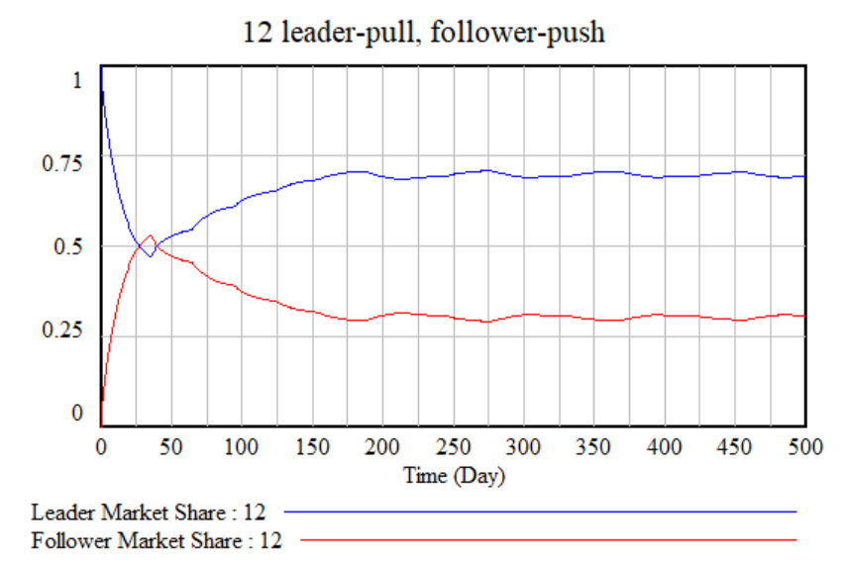

Conversely, if the leader chooses the pull strategy and the follower chooses the push strategy, the leader does not lose the market significantly and succeeds in defending. The leader's average market share for 501 days (from day 0 to day 500) is 06706, and the average for followers is 0.3293. Between the 25th and the 50th, the follower sometimes outpaced the leader, but the leader expanded the pool strategy and took market share from the follower again.

Conclusion

The winner's curse doesn't happen every time. But it happens often. In particular, if the follower follows the leader's strategy, the winner's curse takes place.

Table 1 Market share winner according to leader and follower strategies

|  |  |  |  |  |
| --- | --- | --- | --- | --- |
|  | | Leader’s strategies | | |
| No-expansion(0) | Pull strategy expansion(1) | Push strategy expansion(2) |
| Follower’s stretegies | No-expansion(0) | F=L | F<L | F<L |
| Pull strategy expansion (1) | F>L | F>L | F>L |
| Push strategy expansion(2) | F>L | F<L | F>L |

If the follower chooses the same strategy when the leader does not choose the expansion strategy, when expanding the pull strategy, or when expanding the push strategy, the follower can have a higher market share than the leader. In particular, when the leader chooses the push strategy, if the followers follow the push strategy, the followers can gradually expand their market share.

On the other hand, the leader can regain market share only if the follower chooses the pull strategy if the follower chooses the push strategy. Therefore, the leader's strategy choice is conditional. This is a condition for followers to choose a push strategy.

In this situation, if both the leader and the follower are fully informed, the leader will choose the full strategy. Followers should also choose a pull strategy to increase their market share. 11 is considered to be a Nash Equilibrium situation.

부록1. <그림 4> 모델에서 사용된 변수들과 수식들

Average Adoption Life=10

Decisiontime=30

Desired Follower Adoption Rate=Follower Adoption from Pull+Follower Adoption from Push

Desired Leader Adoption Rate=Leader Adoption from Pull+Leader Adoption from Push

Follower Adopter= INTEG (Follower Adoption Rate-Follower Discard Rate,0)

Follower Adoption Fraction=DELAY3(Follower Push Investment, Push Delay)

Follower Adoption from Pull=Potential Adopter*Follower Pull Fraction

Follower Adoption from Push=Follower Adopter*Follower Adoption Fraction*XIDZ( Total Population-Leader Adopter-Follower Adopter, Total Population, 0)

Follower Adoption Rate=MIN(Desired Follower Adoption Rate, Potential Adopter*XIDZ(Desired Follower Adoption Rate, Desired Follower Adoption Rate+Desired Leader Adoption Rate, 0))

Follower Discard Rate=Follower Adopter/Average Adoption Life

Follower Investment Choice=IF THEN ELSE(MODULO( Time, Decisiontime)=1:AND:Follower Market Share Difference>0, 2, 0)

Follower Market Share Difference=Follower Target Market Share-Follower Market Share

Follower Market Share= XIDZ(Follower Adopter, Follower Adopter+Leader Adopter, 1)

Follower Pull Chunk=IF THEN ELSE(Follower Investment Choice=1, Pull Unit Chunk, 0)

Follower Pull Fraction= DELAY3(Follower Pull Investment, Pull Delay)

Follower Pull Investment= INTEG (Follower Pull Chunk, Pull Unit Chunk)

Follower Push Chunk=IF THEN ELSE(Follower Investment Choice=2, Push Unit Chunk, 0)

Follower Push Investment= INTEG (Follower Push Chunk,Push Unit Chunk)

Follower Target Market Share=0.7

Leader Adopter= INTEG (-Leader Discard Rate+Leader Adoption Rate,Leader Initial Adopter)

Leader Adoption from Pull=Leader Pull Fraction*Potential Adopter

Leader Adoption from Push=Leader Adopter*Leader Push Fraction*XIDZ( Total Population-Leader Adopter-Follower Adopter, Total Population, 0)

Leader Adoption Rate=MIN(Desired Leader Adoption Rate, Potential Adopter*XIDZ(Desired Leader Adoption Rate, Desired Follower Adoption Rate+Desired Leader Adoption Rate, 0))

Leader Discard Rate=Leader Adopter/Average Adoption Life

Leader Initial Adopter=50

Leader Investment Choice=IF THEN ELSE(MODULO( Time, Decisiontime)=0 :AND:Leader Market Share Difference>0, 2, 0)

Leader Market Share Difference=Leader Target Market Share-Leader Market Share

Leader Market Share=XIDZ(Leader Adopter, Leader Adopter+Follower Adopter, 1)

Leader Pull Chunk=IF THEN ELSE(Leader Investment Choice=1, Pull Unit Chunk, 0)

Leader Pull Fraction=DELAY3(Leader Pull Investment, Pull Delay)

Leader Pull Investment= INTEG (Leader Pull Chunk,Pull Unit Chunk)

Leader Push Chunk=IF THEN ELSE(Leader Investment Choice=2, Push Unit Chunk, 0)

Leader Push Fraction=DELAY3( Leader Push Investment, Push Delay)

Leader Push Investment= INTEG (Leader Push Chunk,Push Unit Chunk)

Leader Target Market Share=0.7

Potential Adopter= INTEG (Leader Discard Rate+Follower Discard Rate-Leader Adoption Rate-Follower Adoption Rate, Total Population-Leader Initial Adopter)

Pull Delay=5

Pull Unit Chunk=0.05

Push Delay=5

Push Unit Chunk=0.05

Total Population=100

FINAL TIME = 500

INITIAL TIME = 0

TIME STEP = 1